BHARAT SHRINIVAS HEGDE
CSE 3D
1BM25CS413-T (Diploma)

LAB PROGRAM 01
Write a program to simulate the working of stack using an
array with the following:
a) Push
b) Pop
c) Display
The program should print appropriate messages for stack
overflow, stack underflow.

Code:
#include <stdio.h>

#define MAX 5

int stack[MAX];
int top = -1;

// PUSH operation
void push() {
int value;
if (top == MAX - 1) {
printf("Stack Overflow! Cannot push.\n");
} else {
printf("Enter the element to push: ");
scanf("%d", &value);

top++;
stack[top] = value; // Store value first
printf("Element %d pushed into the stack.\n", value);
}
}

// POP operation
void pop() {
if (top == -1) {
printf("Stack Underflow! Nothing to pop.\n");
} else {
printf("Popped element: %d\n", stack[top]);
top--;
}
}

// DISPLAY operation
void display() {
if (top == -1) {
printf("Stack is empty.\n");
} else {
printf("Stack elements are:\n");
for (int i = top; i >= 0; i--) {
printf("%d\n", stack[i]);
}
}
}

int main() {
int choice;

while (1) {
printf("\n____STACK MENU____\n");
printf("1. PUSH\n");
printf("2. POP\n");
printf("3. DISPLAY\n");
printf("4. EXIT\n");

printf("Enter your choice : ");
scanf("%d", &choice);

switch (choice) {
case 1: push(); break;
case 2: pop(); break;
case 3: display(); break;
case 4:
printf("Exiting program.\n");
return 0;
default:
printf("Invalid choice! Try again.\n");
}
}

return 0;
}

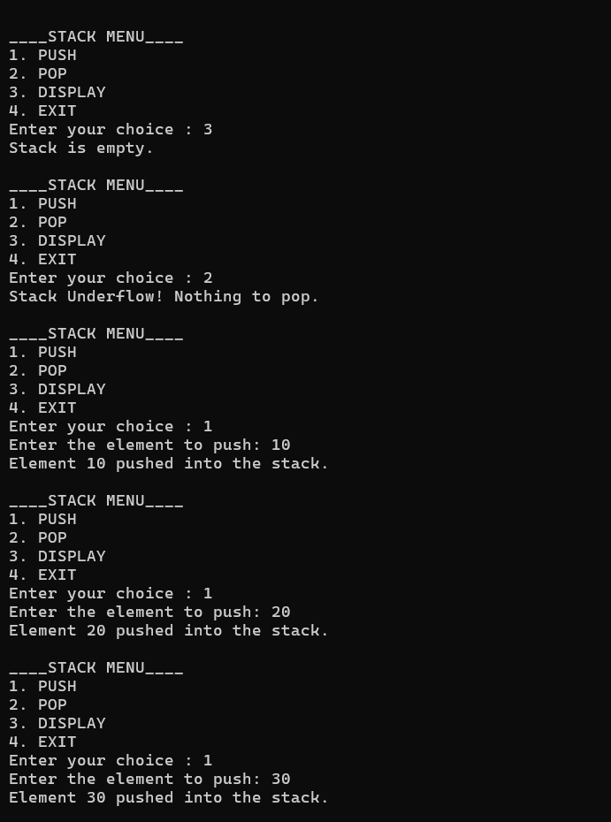
Output:
